SMART TOURISM FORECASTING & ANALYTICS
RESEARCH PAPER

G. Lakshmi Dhara Hasini  2420030421  CSE | G. Lakshmi Keertana  2420090075  CSIT | S. Rishitha  2420090060  CSIT
GUIDE NAME | Dr. K. Swapnika

ABSTRACT
Tourism demand can change quickly because of holidays, weather, online attention, events, transport conditions, prices and changes in traveller behaviour. This makes planning difficult for hotels, attractions, transport providers and destination authorities. This paper proposes a smart tourism forecasting and analytics framework that combines historical visitor demand with supporting signals such as search interest, online reviews, weather, calendar effects and destination events. The aim is to turn scattered information into forecasts that can be understood and used in everyday decisions.
The proposed workflow covers data collection, cleaning, temporal alignment, feature engineering, exploratory analysis, forecasting, model comparison, explainability and decision support. Classical statistical models are kept as transparent baselines, while machine-learning and deep-learning approaches are considered when the available data justify their complexity. A leakage-free temporal validation strategy is emphasized so that information from the future does not accidentally influence the past.
The practical purpose of the framework is broader than improving a metric. Forecasts can support pricing, marketing allocation, staffing, transport preparation, visitor-flow management and resource planning. The paper also links forecasting with sustainable tourism and SDGs 8, 9, 11, 12 and 13. The final empirical version should populate the results tables using the selected destination dataset and measured model outputs.
Keywords: smart tourism; tourism demand forecasting; multi-source data; machine learning; time series; destination management; explainable AI; sustainable tourism; pricing analytics; SDGs
1. INTRODUCTION
1.1 Background
Tourism demand is often described using arrivals, hotel occupancy or visitor spending. In practice, however, many other things can change the number of visitors. A normal week can become very busy because of a festival, school holiday, good weather or a sudden increase in online interest. Such changes affect businesses as well as transport, public spaces, local services and visitors themselves. For this reason, forecasting can be useful at different levels, from deciding hotel staffing to planning transport capacity in a destination.
Smart tourism makes use of digital information to support these decisions before problems occur. Past demand shows the usual pattern, while search activity, reviews, weather and event information can help explain changes from that pattern. Recent studies have started combining these sources instead of relying only on historical demand. For example, Fu and Qin combined search, review and weather information with signal processing and XGBoost for short-term tourism demand forecasting. [1]
1.2 Problem Statement
A major difficulty is that tourism data come from many different sources. These sources may use different time intervals, have different levels of quality and become available at different times. There is also a risk of getting an unrealistically good model if information from the future is used during training. Therefore, the problem is not just predicting visitor numbers. The information needs to be combined in a realistic way and the resulting forecast should also be understandable and useful.
Core research problem: How can information from several tourism-related sources be combined to produce reliable, understandable forecasts that help businesses make better decisions while also supporting sustainable destination management?
1.3 Research Gap
Earlier studies have proposed useful statistical, machine-learning and deep-learning methods, but some practical issues are still open. A large part of the literature concentrates on prediction accuracy, while less attention is given to what managers should do with the forecast. The time at which different data become available is also important because it affects the risk of data leakage. In addition, complex models can be difficult for non-technical users to understand. There is also room to connect forecasting more directly with crowd management, efficient resource use and climate-related planning.
1.4 RESEARCH OBJECTIVES, QUESTIONS AND CONTRIBUTIONS
1.4 Research Objectives
1. Design a multi-source tourism forecasting framework using demand history and relevant external signals.
2. Compare statistical, machine-learning and deep-learning approaches under a common temporal evaluation design.
3. Apply careful preprocessing and time-aware feature engineering to reduce leakage and data-quality problems.
4. Measure forecast accuracy, stability, uncertainty and performance during important peak periods.
5. Translate forecasts into pricing, marketing, staffing, destination-management and sustainability actions.
1.5 Research Questions
• RQ1: Does combining demand history with external tourism signals improve forecasting usefulness?
• RQ2: Which approach offers the best balance between accuracy, stability and interpretability?
• RQ3: How sensitive are forecasts to holidays, weather, online attention and unusual events?
• RQ4: How can forecast information support tourism growth without creating unnecessary crowding or resource pressure?
1.6 Contributions
• A practical end-to-end multi-source forecasting architecture.
• A fair comparison of simple and advanced forecasting methods.
• A leakage-aware temporal validation procedure.
• An explainability layer that connects model outputs with understandable factors.
• A decision layer that considers both commercial performance and sustainability.
1.7 Organization of the Paper
Section 2 discusses earlier research in tourism forecasting. Section 3 presents the proposed methodology, while Section 4 explains how the experiments can be carried out. Section 5 describes the results and how they should be evaluated. Section 6 discusses the meaning of the findings for industry and society. Section 7 covers the main limitations, and Section 8 gives the conclusion and possible future work.
2. RELATED WORK
2.1 Existing Approaches
Tourism demand has traditionally been forecast using statistical time-series methods. Moving averages, exponential smoothing, ARIMA and seasonal ARIMA are useful for capturing repeated patterns and changes over time. They are still important because their behaviour is easier to explain and they provide a clear baseline for comparing more complicated models. They can also perform well when a destination has a stable seasonal pattern.
A model based only on past demand has one obvious weakness: the future does not always behave like the past. A new event, changes in flight availability or growing online interest can produce a sudden increase that historical values alone may miss. ARIMAX is useful in this situation because it allows external variables to be added to a traditional time-series model.
2.2 Machine Learning / Computational Approaches
Machine-learning models provide another way to study tourism demand by learning relationships among several input features. Linear regression is useful as a simple and interpretable comparison. Random Forest and gradient-boosted trees can capture nonlinear effects between demand, weather, calendar variables and online signals. XGBoost is especially suitable for structured data because it can handle several different predictors without the very large datasets that some deep-learning methods need. Recent tourism research has also combined XGBoost with denoising and decomposition techniques. [1]
2.3 Deep Learning
LSTM networks are commonly used when the order of past observations is important. They have been studied for hotel occupancy and tourism demand forecasting. A systematic review covering 50 resort hotel occupancy studies found LSTM to be one of the frequently used deep-learning approaches, with MAPE among the commonly reported measures. [3] Transformers offer another option because attention can help the model learn relationships over longer periods and, in some cases, across different locations. A 2024 study used a spatiotemporal transformer to represent time and location effects before combining them. [2]
2.4 ADVANCED AND ALTERNATIVE APPROACHES
Hybrid methods are useful when a tourism series contains more than one pattern. For example, a demand series may have a long-term trend, a seasonal pattern and shorter-term fluctuations at the same time. Decomposition methods can separate these parts before a forecasting model is applied. Recent work has combined seasonal-trend decomposition with search, weather and holiday information and an LSTM model. [4] Other research has also explored decomposition as a way to improve AI-based forecasting when the available data are limited. [5]
2.5 Explainability and Interpretability
A forecast can affect pricing, staffing, visitor access and the use of public resources, so the final number is not always enough. A manager may want to know why demand is expected to increase and whether the change is related to a holiday, online interest or weather. Feature importance, permutation importance and SHAP-based methods can make the model output easier to interpret by showing which inputs were important for a prediction.
These explanations should still be interpreted carefully. If search interest is an important feature, it does not prove that searches directly cause more arrivals. It only shows that the variable was useful for prediction in the data used. For this reason, explanations should be treated as supporting evidence and checked to see whether the same pattern appears across different periods.
2.6 Multi-source Tourism Data
Source | Potential signal | Main challenge
Historical arrivals | Demand, seasonality, momentum | Missing or delayed records
Search activity | Early public interest | Noise and platform changes
Online reviews | Experience and popularity | Text bias and timing
Weather | Outdoor travel conditions | Forecast uncertainty
Events / holidays | Planned demand shocks | Incomplete event records
Accommodation | Booking pressure | Access and privacy
Mobility | Movement intensity | Privacy and coverage
Table 1. Examples of multi-source tourism signals and their practical limitations.
2.7 CRITICAL COMPARISON
Study / Publication | Key contribution | Limitation / implication
Fu & Qin, 2026 [1] | Multi-source demand forecasting with denoising, decomposition and XGBoost. | Single-destination validation limits direct generalization.
Spatiotemporal Transformer, 2024 [2] | Captures temporal and spatial relationships among attractions. | Higher complexity and data requirements.
Hotel forecasting review, 2023 [3] | Synthesizes 50 deep-learning studies and common metrics. | Focused mainly on hotel occupancy.
Zhang et al., 2026 [4] | Combines decomposition, search, weather, holidays and LSTM. | Broader destination testing is still useful.
Zhang et al. [5] | Uses decomposition to improve deep-learning tourism forecasts. | Operational transfer needs further study.
Núñez et al., 2024 [6] | Reviews machine learning across tourism applications. | Broad review rather than one forecasting benchmark.
Horizon 2050 review, 2025 [7] | Summarizes methodological development and future research needs. | Narrative review rather than a single empirical benchmark.
Table 2. Comparison of representative tourism forecasting studies.
2.8 Research Gap (Summary)
Overall, the literature shows a gradual move from single-source statistical models toward multi-source machine learning, deep learning and hybrid methods. A useful next step is to connect prediction quality with the decisions that follow the forecast. The proposed framework does this by keeping simple baselines, using time-based validation, explaining important inputs and linking the forecast with pricing, marketing, visitor-flow and resource decisions.
3. PROPOSED METHODOLOGY
3.1 Overall Framework
The proposed workflow is organized in a practical order. First, the required data are collected and checked. The different sources are then aligned by time, useful features are created, and the candidate models are trained. After that, the models are evaluated using the same rules, the predictions are explained, and the results are connected to possible decisions. In this study, preprocessing and validation are treated as important parts of the forecasting process rather than as separate steps.
The proposed methodology follows an end-to-end data-driven approach for forecasting tourism demand and converting the forecasting results into practical tourism management decisions. The methodology begins with the collection of historical tourism demand data and supporting information from multiple sources. These sources may include visitor arrivals, hotel bookings, search trends, weather conditions, holidays, festivals, events, online reviews, transportation information and other relevant tourism indicators. Combining these sources provides a broader representation of the factors that influence tourism demand rather than depending only on historical visitor numbers.
After collecting the data, the different datasets are integrated into a common analytical structure. Since different sources may use different date formats, time intervals and measurement units, temporal alignment is performed before modelling. The data are then cleaned by identifying missing values, duplicate observations and unusual values. The preprocessing stage is particularly important because poor-quality input data can directly affect the reliability of the forecasting results. The methodology therefore treats data preparation as an important part of the forecasting system rather than as a preliminary activity performed independently.
The next stage involves exploratory data analysis to understand the major patterns present in tourism demand. Historical demand is examined to identify increasing or decreasing trends, weekly patterns, seasonal variations and unusual peaks. Relationships between demand and external factors such as holidays, weather and search activity are also investigated. These observations are used to guide the selection of suitable features and forecasting models. However, visual patterns are treated as indications rather than proof of causality, since a relationship observed in historical data does not necessarily mean that one factor directly causes changes in tourism demand.
ssss
Input | Processing | Forecast | Decision
Arrivals | Cleaning and alignment | Seasonal baseline | Pricing
Search trends | Lag / rolling features | ARIMA / ARIMAX | Marketing
Reviews | Sentiment / volume | Random Forest / XGBoost | Staffing
Weather | Calendar alignment | LSTM / Transformer | Capacity
Events | Encoding | Ensemble | Sustainability
Fig. 1. Proposed smart tourism forecasting pipeline.
3.2 Dataset(s)
At minimum, the project needs a time-stamped tourism demand series. The analysis becomes more informative when it also includes search activity, weather, events, reviews and, where available, accommodation or mobility information. The choice of data should match the forecast horizon. For example, daily forecasting needs daily information or variables that can be converted to a daily level, while weekly forecasting can use weekly summaries.
• Historical tourism demand — daily or weekly arrivals, visits, bookings or occupancy.
• Search interest — destination-related search indices or query volumes.
• Weather — temperature, precipitation, humidity or condition indicators.
• Calendar and events — weekends, holidays, school breaks, festivals and major events.
• Reviews — count, rating and, when ethically and technically appropriate, aggregated sentiment.
The supplied template did not include the actual project dataset. Therefore, the final paper should add the real dataset name, source, time period and number of records once the data collection is complete.
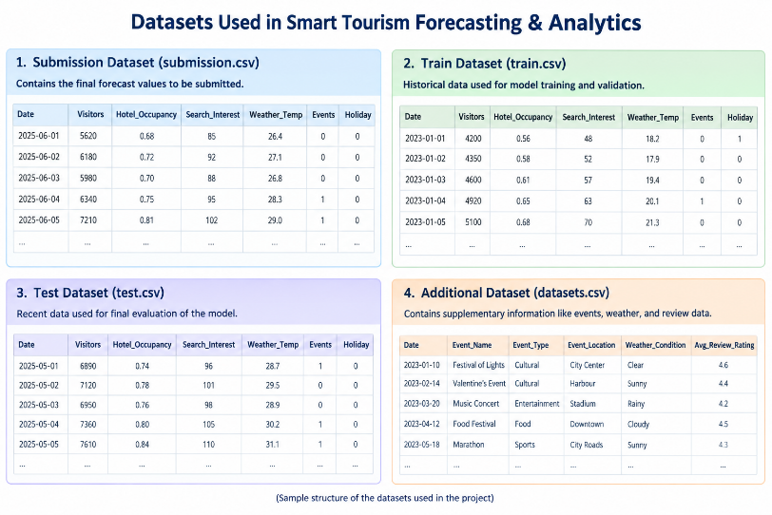
Overall System Architecture:
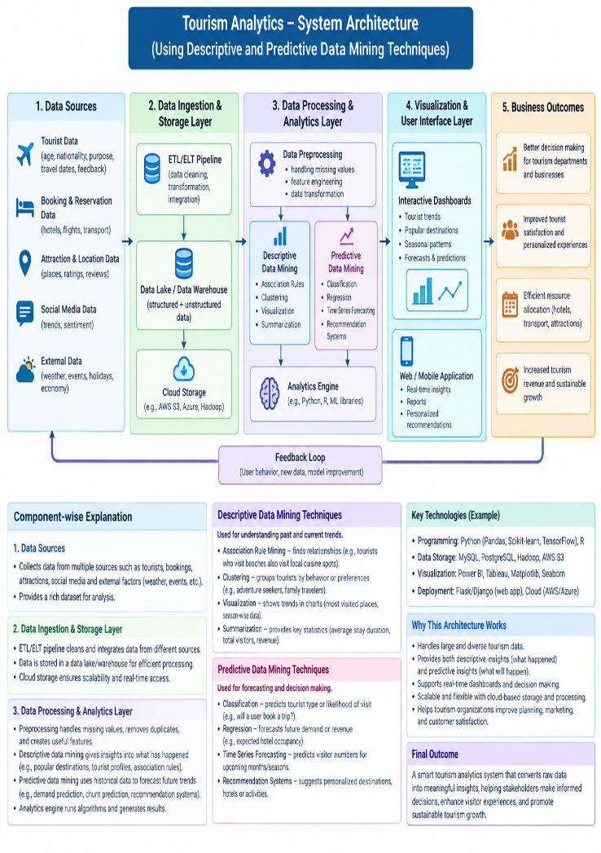
System Workflow
The system operates through the following steps:
Step 1: Collect tourism data from different sources.
Step 2: Store the collected data in a database.
Step 3: Clean and preprocess the data.
Step 4: Apply descriptive data mining to identify historical patterns.
Step 5: Apply predictive data mining to forecast future tourism trends.
Step 6: Display the results using interactive charts and graphs.
Step 7: Allow users to explore the results through the dashboard.

3.3 DATA PREPROCESSING
Missing values
Missing values should be checked before deciding how to handle them. For example, a missing visitor count could be a reporting issue, but it could also mean that a location was closed. External variables need similar care. Weather data should not be carried forward for a long period without checking whether that makes sense, while calendar information can often be reconstructed from known dates.
Duplicates and outliers
Duplicate records can make visitor or review counts look higher than they really are, so they should be identified and removed using clear rules. At the same time, an unusual value is not necessarily an error. A festival or holiday may create a genuine peak. Such observations should be checked first, and known events can be included as features when that information would have been available before the forecast was made.
Temporal alignment
Each input variable has to be available at the time the forecast is supposed to be made. For example, a review posted after a visit should not be used to predict the number of visitors on that same day. In the same way, an observed weather value that became available later cannot be used for an earlier forecast. Keeping this timing rule clear helps avoid misleadingly high model performance.
Encoding and scaling
• Encode weekday, month and event categories appropriately.
• Create lag features using past values only.
• Create rolling averages from information available before the forecast time.
• Scale variables when the selected algorithm requires it.
• Fit transformations on training data and apply them unchanged to future periods.
3.4 Exploratory Analysis
The initial data analysis should focus on patterns that may matter for forecasting. These include seasonality, long-term trends, holiday effects, changes in search interest, weather-related changes, unusual peaks and shifts in visitor behaviour. The purpose of this step is not to prove a relationship from a chart alone. Instead, the patterns found here can guide the features and models used later.
3.4 FEATURE ENGINEERING
Time features
Tourism data commonly show daily, weekly and yearly patterns. Features such as weekday, month, holiday status, time until an event, recent demand change and seasonal lag values can capture these patterns. Cyclical encoding is also useful because it represents repeating calendar values without treating the end of a cycle as completely separate from its beginning.
Search features
Search activity can provide an early indication that people are becoming interested in a destination. Both the current level and recent change in searches may be useful. A sudden rise can sometimes be more informative than a consistently high value. However, online interest does not always lead to actual travel, so the usefulness of search features needs to be tested rather than assumed.
Review features
Review count, average rating and aggregated sentiment can give some information about visitor experience. The timing of reviews is important here. If most reviews are posted after the visit, they may be useful for predicting later demand but not the demand on the same day. Treating this timing correctly helps keep the forecast realistic.
Weather features
Weather does not always affect tourism in a simple straight-line way. Comfortable conditions may encourage outdoor travel, while very high temperatures or heavy rain may discourage it. Possible features include temperature ranges, rainfall indicators and previous-day weather. If the system is intended to make forecasts before the travel date, forecasted weather rather than later observed weather should be used.
Interaction features
Some effects may become stronger when they occur together. For instance, a holiday, good weather and rising search interest could produce a larger increase in demand than any one of these factors alone. Tree-based models can learn many such interactions automatically. For simpler regression models, selected interaction terms can be added explicitly.
3.5 PROPOSED MODELS AND BASELINES
Seasonal Naïve
The seasonal naïve model uses the value from the previous comparable season as the forecast. It is intentionally simple, but it gives the project an important reference point. If a more complicated model cannot improve on this baseline consistently, there may be little reason to use the extra complexity.
ARIMA / SARIMA
ARIMA and SARIMA models are useful for representing relationships between past observations, changes in the series and seasonal behaviour. They are relatively easy to inspect and do not require very large amounts of data, which makes them useful baseline models for this study.
ARIMAX
ARIMAX adds external variables to the traditional time-series approach. This makes it useful for testing whether information such as search interest, weather or events provides an improvement over using past demand alone.
Machine-learning candidates
• Linear Regression — interpretable additive benchmark.
• Random Forest — nonlinear ensemble for structured data.
• XGBoost — gradient-boosted trees for nonlinear relationships and interactions.
• Support Vector Regression — flexible nonlinear regression candidate.
Deep-learning candidates
• LSTM — sequence model for temporal dependencies.
• Temporal Transformer — attention-based model for longer-range relationships.
• Spatiotemporal model — extension for several attractions or destinations.
Ensemble option
An ensemble can combine predictions from different models when their strengths are complementary. However, it should only be used if the validation results show a clear benefit. The purpose is not to make the project look more complicated; it is to obtain a more stable and useful forecast.
Literature Survey
- Tourism research is increasingly using AI, ML, deep learning, and big data analytics.
- Hybrid models such as ARIMA-LSTM improve tourism demand forecasting.
- Deep learning helps capture complex and nonlinear tourism patterns.
- Data mining supports tourist behavior analysis and personalized recommendations.
- ML models are applied to hotel occupancy and cancellation prediction.
- Big data analytics enables better destination planning and decision-making.
- There is a growing need for integrated smart tourism systems that combine forecasting, personalization, and real-time analytics.

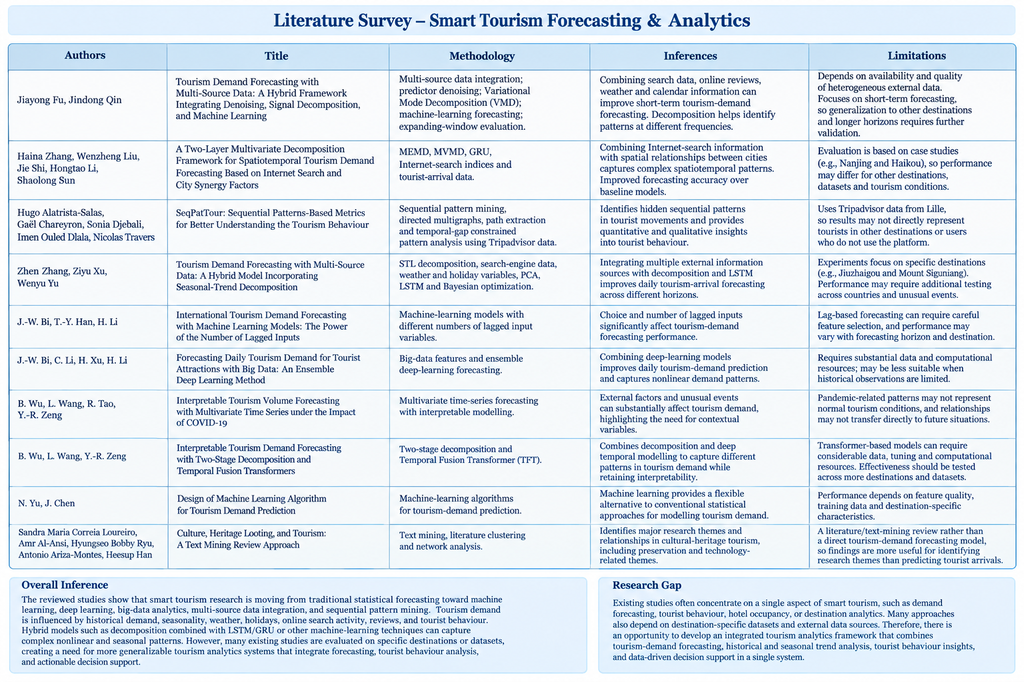
3.6 ALGORITHMIC / MATHEMATICAL FORMULATION
Let y_t denote tourism demand at time t. Let X_t represent the external information that is available when the forecast is made, and let ŷ_(t+h) denote the forecast h steps into the future.
ŷ_(t+h) = f(y_t, y_(t−1), …, y_(t−p), X_t, X_(t−1), …, X_(t−q))
(1)
The form of f depends on the model being used. In ARIMAX, it describes a statistical time-series relationship with external variables. In XGBoost, it is represented by a group of decision trees, while an LSTM learns patterns from sequences of past observations. Using the same target with these different models makes it possible to compare several modelling approaches fairly.
Evaluation metrics
The performance of the tourism forecasting model is evaluated using Mean Absolute Error (MAE), Root Mean Square Error (RMSE), and Mean Absolute Percentage Error (MAPE). These metrics measure the difference between the actual tourism demand and the demand predicted by the model.
1. Mean Absolute Error (MAE)
$$MAE=\frac{1}{n}\sum_{t=1}^{n}{∣}y_{t}-{\hat{y}}_{t}∣$$
MAE represents the average absolute difference between actual and predicted tourism demand. A lower MAE indicates that the model's predictions are closer to the actual number of tourists, bookings, or visitors. Since MAE is expressed in the same unit as the target variable, it is easy for tourism managers to interpret.
2. Root Mean Square Error (RMSE)
$$RMSE=\sqrt{\frac{1}{n}\sum_{t=1}^{n}{(}\left.y_{t}-{\hat{y}}_{t}{\left.)\right.}^{2}\right.}$$
RMSE gives greater importance to large forecasting errors because the errors are squared before averaging. This is particularly useful in tourism forecasting because a large prediction error during peak seasons, holidays, or major tourism events can affect staffing, hotel capacity, transportation, and resource planning.
3. Mean Absolute Percentage Error (MAPE)
$$MAPE=\frac{100}{n}\sum_{t=1}^{n}{∣\frac{y_{t}-{\hat{y}}_{t}}{y_{t}}∣}$$
MAPE expresses the forecasting error as a percentage, making it easy to understand and compare across different tourism periods or destinations. A lower MAPE indicates better forecasting performance. However, MAPE can become unreliable when the actual tourism demand is zero or very close to zero. Therefore, sMAPE or MAE can be considered for such periods.
Performance Interpretation
For our tourism analysis project, the model performance can be interpreted as follows:
Metric | What it measures | Tourism interpretation
MAE | Average prediction error | Average number of tourists/bookings the model misses
RMSE | Penalizes large errors | Detects major forecasting errors during peak periods
MAPE | Percentage error | Shows forecasting accuracy in percentage terms
sMAPE | Symmetric percentage error | Useful when demand values vary significantly or are close to zero
Model Performance Comparison
If your project compares multiple forecasting models, you can present the results in this format:
Model | MAE | RMSE | MAPE
ARIMA | [value] | [value] | [value]%
Random Forest | [value] | [value] | [value]%
LSTM | [value] | [value] | [value]%
Hybrid ARIMA-LSTM | [value] | [value] | [value]%
Interpretation: The model with lower MAE, RMSE, and MAPE provides predictions that are closer to the actual tourism demand. The comparison helps identify how effectively different forecasting approaches capture seasonality, tourist trends, peak periods, and changes in demand.
Uncertainty
A single predicted value does not show how uncertain the forecast is. Prediction intervals or quantile forecasts can give managers a range of possible demand, which is more helpful when planning capacity. Methods such as conformal prediction, quantile regression and probabilistic sequence models could be explored in a later version of the project.
4. EXPERIMENTAL SETUP
4.1 Hardware and Software
The project can be implemented in Python. Pandas and NumPy can be used for data preparation, statsmodels for statistical forecasting, scikit-learn for machine-learning models, XGBoost for boosted trees, and PyTorch or TensorFlow for deep learning. Jupyter Notebook or Google Colab can be used for experiments, while Git can keep track of code and preprocessing changes.
Component | Technology | Purpose
Programming | Python | Main implementation
Data | Pandas / NumPy | Cleaning and features
Statistics | statsmodels | ARIMA-family models
ML | scikit-learn / XGBoost | Model comparison
DL | PyTorch / TensorFlow | LSTM / Transformer
Plots | Matplotlib | Analysis and results
Version control | Git / GitHub | Reproducibility
4.2 Dataset Split / Design
The dataset should be split according to time rather than randomly. Random splitting can place future observations in the training data and make the model look better than it would in real use. A starting point could be 70% for training, 15% for validation and 15% for testing, but the final split should depend on how much data are available and whether the important seasonal periods are covered.
4.3 Hyperparameter Configuration
Hyperparameters should be selected using only the training and validation data. For XGBoost, useful settings to tune include learning rate, tree depth, number of estimators and subsampling. For LSTM, sequence length, hidden units, dropout and learning rate are important. Transformer models may require choices such as context length, attention size and number of layers. When the dataset is small, a limited and controlled search is safer than a very large search.
4.4 VALIDATION STRATEGY
Expanding-window validation is suitable for this problem because it follows the way forecasting would happen in practice. The model first learns from an initial historical period, makes a forecast for the next period, and then adds the newly available observations before making the next forecast. Repeating this process gives a better idea of how stable the model is over time.
Fold | Training | Validation / evaluation
1 | Initial history | Next period
2 | History + fold 1 | Next period
3 | History + folds 1–2 | Next period
4 | History + folds 1–3 | Next period
Table 3. Simplified expanding-window validation design.
4.5 Evaluation Metrics
• MAE for average absolute error.
• RMSE for sensitivity to large misses.
• MAPE or sMAPE for percentage-oriented comparison.
• Prediction-interval coverage for uncertainty quality.
• Peak-period error for operational robustness.
• Business metrics such as staffing mismatch, overcrowding risk or campaign efficiency.
4.6 Statistical Testing
A small difference between two average error values does not necessarily mean that one model is genuinely better. Where the data and study design allow it, forecast-error tests such as the Diebold–Mariano test can be used. Repeated rolling comparisons are also useful because they show whether a model performs well across several periods instead of only during one favourable period.
4.7 Reproducibility
For reproducibility, the project should keep a record of the dataset version, time period, preprocessing decisions, feature definitions, random seeds, hyperparameters, software versions and evaluation windows. Keeping these details together makes it easier to repeat the experiment and update the model later.
5. RESULTS
The current project material does not include the tourism dataset or completed model results. Therefore, this section does not report made-up accuracy values. Instead, it explains how the results should be presented after the real experiments are completed. This keeps the paper consistent with the available evidence.

5.1 Overall Performance
The main result should show whether adding several information sources improves on the strongest model that uses only historical demand. Performance should be checked across more than one time period. A model that works well during ordinary weeks but performs poorly during holidays or unusual weather may not be reliable enough for real operational use.
5.2 Model / Method Comparison
Method | MAE | RMSE | MAPE/sMAPE | Interpretation
Seasonal Naïve | To measure | To measure | To measure | Seasonal reference
SARIMA | To measure | To measure | To measure | Statistical baseline
ARIMAX | To measure | To measure | To measure | External variables
Random Forest | To measure | To measure | To measure | Nonlinear benchmark
XGBoost | To measure | To measure | To measure | Structured-data candidate
LSTM | To measure | To measure | To measure | Sequence candidate
Transformer | To measure | To measure | To measure | Attention candidate
Ensemble | To measure | To measure | To measure | Combined forecast
Table 4. Empirical results table to be completed from the actual project run.
5.3 Result Reporting Rule
Whenever a numerical result is added, the paper should also state the dataset period, forecast horizon and evaluation method. A score is much easier to understand when the reader knows how and where it was obtained.
5.4 ERROR AND SCENARIO ANALYSIS
Average error does not always tell the whole story. A model may have a reasonable overall score but still make large mistakes during the busiest periods. The final analysis should therefore look separately at ordinary days, holidays, peak weekends, difficult weather and unusual events.
Peak-demand analysis
If the model predicts too few visitors during a peak, businesses may face staff shortages, queues or transport pressure. Predicting too many visitors can also waste money because extra staff or resources may be arranged unnecessarily. For this reason, the final study should report errors specifically for high-demand periods.
Low-demand analysis
Low-demand periods are also important. If weak demand can be identified early, businesses can focus promotions on those periods instead of offering discounts everywhere. Percentage-based metrics should be read carefully when the actual number of visitors is very small.
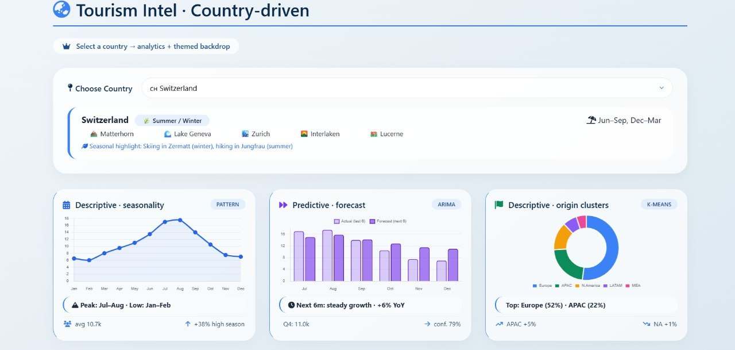
Event analysis
Events need to be treated according to when the information became known. A festival announced before the forecast date can reasonably be used as an input. If the event was only known after the forecast period, including it would give the model information it could not have had at the time. The final study should make this timing clear.
5.5 Feature / Factor Importance
Feature-importance analysis can help show which inputs are being used strongly by the model. Possible factors include recent demand, seasonal lags, search interest, weather, holidays and events. SHAP or permutation importance can be used for tree-based models. The actual ranking should only be reported after the model has been trained and tested.
5.6 EXPECTED RESULTS AND DECISION VALUE
The value of the framework should not be judged only by whether it lowers an error metric. A useful forecast should give some early warning, show uncertainty where possible and help a manager decide what to do next. In some situations, a stable and understandable model may be more useful than a slightly more accurate model that is difficult to interpret or maintain.
Expected finding 1: external signals add context
Past demand will probably remain an important input because tourism usually has some persistence and seasonality. Search activity, weather and event information may help explain why demand moves away from its usual pattern. However, the final experiment should measure the contribution of these variables instead of assuming that they will improve the forecast.
Expected finding 2: complexity needs evidence
Models that can learn nonlinear relationships may perform well when many external factors interact. At the same time, deep-learning models may be difficult to train reliably when the dataset is short. The final comparison should therefore consider both predictive performance and the practical effort needed to use each model.
Expected finding 3: peak robustness matters
For many tourism decisions, mistakes during peak periods matter more than small errors on ordinary days. The final results should therefore check whether the selected model remains dependable when demand is unusually high or when conditions change quickly.
Expected finding 4: explanations improve usability
A manager can usually act more easily on a simple explanation than on a model score alone. For example, the system might indicate that demand is expected to rise because a holiday is approaching, search interest has increased and the weather is favourable. Such explanations should support decisions, but they should not be presented as proof that these factors caused the increase.
6. DISCUSSION
6.1 Interpretation of Findings
This framework looks at forecasting as a decision-support task rather than only a modelling exercise. The forecast is useful when it changes a practical decision. A hotel may adjust staffing or inventory, an attraction may prepare for timed entry, a transport operator may plan capacity, and a marketing team may reduce promotion when demand is already expected to be high.
Using several sources also gives a broader picture of what is happening in tourism. Arrivals show realized demand, search activity gives a sense of public interest, reviews provide information about visitor experience, weather describes environmental conditions, and events can signal planned changes. Each source has a different role, so they should be combined carefully while considering their timing and reliability.
6.2 Comparison With Previous Studies
The proposed design is consistent with the direction of recent tourism forecasting research. Fu and Qin combined search, review and weather information with denoising, decomposition and XGBoost. [1] A 2024 study also explored a spatiotemporal transformer for relationships across time and attractions. [2] Recent reviews show that tourism forecasting is increasingly using machine learning and other computational methods. [6][7] This paper extends that direction by putting more emphasis on explainability, practical decisions and sustainability.
6.3 Theoretical Implications
The framework suggests viewing tourism demand in layers. Past demand and seasonal patterns provide the basic structure, while external variables can help explain changes away from that normal pattern. This is one reason the study compares simple statistical models, models with external variables, nonlinear machine-learning methods and hybrid approaches instead of assuming that one type of model will always be best.
6.4 PRACTICAL IMPLICATIONS
Optimized Pricing
Forecasts can help businesses adjust prices when demand is expected to change. Higher expected demand may support a moderate price increase, while weaker periods may be suitable for targeted offers. Still, simply raising prices whenever demand is high can reduce customer trust and make travel less accessible. Pricing decisions should therefore also consider capacity and customer experience.
Marketing Optimization
Marketing teams can use the forecast to decide when a campaign is actually needed. If demand is already expected to be high, extra promotion may create more crowding without much additional benefit. During weaker shoulder periods, a focused campaign may help bring visitors when businesses and destinations still have capacity.
Destination Management
Destination authorities can use demand forecasts when planning transport, parking, visitor information, public spaces and attraction capacity. One of the main benefits is the extra time provided by an early warning. Even if the forecast is not perfect, it can still be useful when it gives managers enough time to prepare.
Hospitality Operations
Hotels, restaurants and tour operators can use demand estimates to plan staff, supplies, inventory and room allocation. If suitable data are available, booking pace and cancellation patterns could also be added. These additional sources should be handled with appropriate privacy and data-governance rules.
Mobility and Infrastructure
Transport providers can use overall demand signals to prepare capacity and communicate possible pressure to travellers. When mobility data are used, aggregated information should be preferred whenever individual-level data are not needed.
6.5 SOCIETY & SDGS
Better Visitor Experiences
Forecasting can help improve the visitor experience by giving destinations a chance to prepare for crowding. If one attraction is expected to become very busy, visitors can be informed about alternative places, timed entry or less busy travel periods. The purpose should be to reduce pressure on the destination while still giving visitors useful choices.
SDG 8 — Decent Work and Economic Growth
Tourism provides jobs and supports many local businesses. Better demand estimates can make it easier to plan seasonal staff and reduce last-minute shortages. Smaller businesses can also use forecasts to prepare for busy periods and quieter periods, which may help them manage their resources more steadily.
SDG 9 — Industry, Innovation and Infrastructure
Smart tourism is one practical use of digital infrastructure. Bringing together tourism, weather, mobility and event information can give planners better evidence when improving infrastructure and visitor services.
SDG 11 — Sustainable Cities and Communities
Large visitor numbers can put pressure on roads, public spaces, transport and local services. Forecasts can help destinations spread visitors across suitable locations, manage access and prepare for busy periods. This can support tourism while also considering the everyday needs of local residents.
SDG 12 — Responsible Consumption and Production
Tourism also increases demand for water, energy, food, cleaning and waste services. Better estimates of visitor numbers can help prepare these resources and avoid unnecessary over-provisioning during quiet periods. Forecasting by itself cannot guarantee responsible consumption, but it can provide useful information for planning.
SDG 13 — Climate Action
Weather and climate information can support tourism planning under changing environmental conditions. Forecasts can help destinations prepare for extreme heat, heavy rain and similar pressures. Over a longer period, tourism data can also be used to study how changing climate conditions may affect visitor demand.
6.6 SUSTAINABILITY-ORIENTED DECISION LAYER
Demand condition | Commercial response | Sustainability response
High demand | Protect inventory; moderate pricing | Disperse visitors; add capacity
Moderate demand | Targeted promotion | Maintain normal service
Low demand | Shoulder-season offers | Avoid unnecessary resource deployment
Extreme weather risk | Flexible booking policies | Protect visitors and sensitive sites
High uncertainty | Flexible staffing | Use conservative capacity assumptions
Table 5. Example of integrating commercial and sustainability decisions.
Visitor Dispersion
Visitor dispersion is a practical example of how forecasting can support sustainability. If one attraction is expected to be overcrowded, the destination can promote suitable alternatives that still have capacity. This can reduce pressure and may also spread tourism spending across a wider area. Information about safety and accessibility should remain clear and should never be hidden simply to make the destination appear less crowded.
Resource-aware Forecasting
A future version of the system could forecast resource needs along with visitor numbers. For example, water, electricity, waste and transport pressure could be estimated as additional outcomes. This could eventually support a destination digital-twin approach in which visitor demand is considered together with the physical capacity of the destination.
Climate-aware Planning
Climate-aware forecasting could support decisions such as changing the timing of outdoor events, preparing cooling facilities or communicating weather-related travel risks. Short-term weather forecasts and long-term climate trends should be kept separate because they are used for different types of planning.
7. LIMITATIONS
• Data dependency — forecasting quality depends strongly on data completeness, frequency and reliability.
• Platform changes — search and review platforms can change their measurement systems over time.
• Leakage risk — predictors published after the forecast time must not be used retrospectively.
• Generalization — a model trained for one destination may not transfer directly to another.
• Rare events — disasters, pandemics and sudden policy changes are difficult to learn from ordinary history.
• Interpretability limits — feature importance describes predictive association, not causality.
• Privacy — mobility, booking and digital traces can contain sensitive information.
• Operational constraints — a forecast cannot create staff or transport capacity instantly.
• Model drift — visitor behaviour changes, so performance must be monitored after deployment.
• Sustainability trade-offs — more accurate demand prediction can still encourage over-tourism unless sustainability constraints are explicit.
7.1 Ethical Considerations
The project should collect only the information that is actually needed for the intended decision. Individual tracking should not be added just because the technology allows it. If personal or behavioural data are used, they should be handled according to relevant privacy requirements, kept only as long as necessary and reported in aggregated form whenever possible.
7.2 Model Governance
If the forecasting system is deployed, someone should be responsible for monitoring it. There should also be a clear fallback process for periods when the data or predictions become unreliable. Unusually high errors or poor data quality should trigger a human review. Model retraining should be based on evidence that visitor behaviour or the underlying tourism pattern has changed.
8. CONCLUSION AND FUTURE WORK
This paper presented a smart tourism forecasting framework that brings together historical demand with search interest, reviews, weather, events and other useful context. It keeps simple statistical models as baselines and considers machine-learning and deep-learning methods when the data support them. Time-based validation is used so that the evaluation is closer to real forecasting. The framework also adds explanations and connects the forecast with pricing, marketing, staffing, destination management and sustainability decisions.
The main point is that a smart tourism system does not need to use the most complicated algorithm to be useful. It needs reliable data, a realistic evaluation process and results that people can understand. Forecasting can support better visitor experiences and more efficient operations, but the benefits are greater when business goals are balanced with the limits and sustainability needs of the destination.
Future Work
1. Run the framework on the actual selected destination dataset and report measured results.
2. Add probabilistic forecasting and prediction intervals.
3. Test multi-destination or transfer-learning approaches.
4. Integrate carefully governed real-time signals such as booking pace or aggregate mobility.
5. Develop a dashboard showing forecasts, uncertainty, factors and suggested actions.
6. Add explicit crowding, resource and climate constraints.
7. Study fairness in automated pricing and marketing recommendations.
8. Monitor model drift and compare retraining strategies.
DECLARATIONS
Funding
No external funding was specified for this research paper.
Conflict of Interest
The authors declare no conflict of interest related to the proposed research framework.
Ethics Statement
The proposed framework is designed to use aggregated or appropriately anonymized information where possible. Any deployment involving personal, booking, mobility or review data should follow applicable privacy, institutional and platform requirements.
Data Availability
The supplied template did not include a project dataset. The final empirical paper should identify the dataset source, access conditions, period, variables and preprocessing code.
Author Contributions
Author One: conceptualization and methodology. Author Two: data collection and preprocessing. Author Three: modelling and evaluation. Author Four: visualization, discussion and review. Replace these descriptions with the actual project contributions.
Acknowledgements
The authors acknowledge their faculty mentor, institution and publicly available scholarly resources supporting research in tourism analytics and sustainable destination management.
REFERENCES
[1] J. Fu and J. Qin, “Tourism demand forecasting with multi-source data: a hybrid framework integrating denoising, signal decomposition, and machine learning,” Management System Engineering, vol. 5, article 6, 2026. DOI: 10.1007/s44176-026-00063-8.
[2] “Tourism demand forecasting: a deep learning model based on spatial-temporal transformer,” Tourism Review, vol. 80, no. 3, pp. 648–663, 2024. DOI: 10.1108/TR-05-2023-0275.
[3] “Forecasting resort hotel tourism demand using deep learning techniques – A systematic literature review,” Heliyon, vol. 9, no. 7, e18385, 2023. DOI: 10.1016/j.heliyon.2023.e18385.
[4] Z. Zhang, Z. Xu, and W. Yu, “Tourism demand forecasting with multi-source data: a hybrid model incorporating seasonal-trend decomposition,” Annals of Operations Research, 2026. DOI: 10.1007/s10479-025-06832-0.
[5] Y. Zhang, G. Li, B. Muskat, and R. Law, “Tourism Demand Forecasting: A Decomposed Deep Learning Approach,” research record/version, 2024.
[6] R. Núñez et al., “Machine learning applied to tourism: A systematic review,” WIREs Data Mining and Knowledge Discovery, 2024. DOI: 10.1002/widm.1549.
[7] “Tourism demand modelling and forecasting: a Horizon 2050 paper,” Tourism Review, vol. 80, no. 1, pp. 8–27, 2025. DOI: 10.1108/TR-12-2023-0882.
[8] J.-W. Bi, T.-Y. Han, and H. Li, “International tourism demand forecasting with machine learning models: The power of the number of lagged inputs,” Tourism Economics, vol. 28, no. 3, pp. 621–645, 2022.
[9] J.-W. Bi, C. Li, H. Xu, and H. Li, “Forecasting daily tourism demand for tourist attractions with big data: An ensemble deep learning method,” Journal of Travel Research, vol. 61, no. 8, pp. 1719–1737, 2022. DOI: 10.1177/00472875211040569.
[10] T. Chen and C. Guestrin, “XGBoost: A scalable tree boosting system,” Proceedings of the 22nd ACM SIGKDD International Conference on Knowledge Discovery and Data Mining, 2016.
[11] W. Cao, M. Hu, S. Wei, and L. Yang, “Denoising search query improves tourism forecasting,” Annals of Tourism Research, vol. 115, article 104049, 2025. DOI: 10.1016/j.annals.2025.104049.
[12] United Nations, “Sustainable Development Goals,” United Nations SDG framework.
APPENDIX A — PROPOSED DASHBOARD CONTENT
For the final project demonstration, a simple dashboard can be used to present the main outputs. It does not need to show every technical detail. Instead, it should make the forecast, uncertainty, important factors and suggested actions easy to see so that a user can decide what to do.
Dashboard card | Example output | Purpose
Demand forecast | Next 7 / 30 days | Planning horizon
Confidence | Low / medium / high | Decision caution
Peak alert | Expected high-demand date | Capacity preparation
Search trend | Rising / stable / falling | Early attention
Weather | Expected conditions | Outdoor planning
Top factors | Holiday / search / weather / lag | Explainability
Business action | Price / campaign / staff | Operational response
Sustainability | Crowding / resource warning | Responsible planning
Example Decision Flow
1. Read the forecast and uncertainty range.
2. Check holidays, events and unusual weather.
3. Review the main factors behind the forecast.
4. Compare expected demand with available capacity.
5. Choose a response that balances revenue, visitor experience and sustainability.
6. Record the decision and later compare the outcome with the forecast.
APPENDIX B — IMPLEMENTATION CHECKLIST
• Define target variable and forecast horizon.
• Document when each predictor becomes available.
• Collect and version raw data.
• Remove duplicates and investigate missing values.
• Create calendar, lag, rolling and external features.
• Build a seasonal naïve baseline.
• Train ARIMA/SARIMA or ARIMAX.
• Train at least two machine-learning models.
• Use deep learning only when data size and problem justify it.
• Use expanding-window validation.
• Evaluate normal and peak periods separately.
• Check systematic underprediction and overprediction.
• Generate feature explanations.
• Add uncertainty estimates where possible.
• Connect forecasts to practical actions.
• Include sustainability constraints.
• Document privacy and data governance.
• Monitor model drift after deployment.
Final Research Message
Smart tourism forecasting is most useful when the data lead to a practical improvement for people and places. A strong project is not necessarily the one with the most complicated algorithm. It should be able to explain where its data come from, show that the evaluation is fair, communicate uncertainty and demonstrate how the forecast can support a real tourism decision.
APPENDIX C — SUGGESTED FIGURES AND TABLES
Item | Recommended content
Figure 1 | Overall smart tourism forecasting pipeline
Figure 2 | Feature engineering and data alignment
Figure 3 | Model performance comparison
Figure 4 | Actual vs predicted demand
Figure 5 | Forecast interval and peak alerts
Figure 6 | Feature importance / SHAP summary
Figure 7 | Visitor-flow dispersion concept
Table 1 | Multi-source data and challenges
Table 2 | Literature comparison
Table 3 | Validation design
Table 4 | Model performance
Table 5 | Commercial and sustainability decisions
The final figures should be created from the actual dataset and model outputs. Numerical values should not be added just to make the paper appear complete; they should come from the real experiments.
Model Selection Guideline
Situation | Starting point | Reason
Short series / strong seasonality | Seasonal Naïve / SARIMA | Simple and stable
External variables | ARIMAX / XGBoost | Uses additional information
Many nonlinear features | XGBoost | Learns interactions
Long sequential data | LSTM / Transformer | Temporal representation
Multiple destinations | Spatiotemporal model | Spatial relationships
High uncertainty | Ensemble / probabilistic | Shows range
Operational use | Baseline + advanced model | Reduces dependence on one model
For a student project, a practical path is to start with a clean baseline, add the external features, compare XGBoost with a statistical model, and then try one deep-learning model if the dataset is suitable. This gives a useful comparison without making the implementation harder than necessary.

